Step to create certificate :

1. Goto Aws Console.
2. Search ACM(AWS Certificate Manager).
3. Then click on [**Request a certificate**](https://ap-south-1.console.aws.amazon.com/acm/home?region=ap-south-1#/certificates/request).

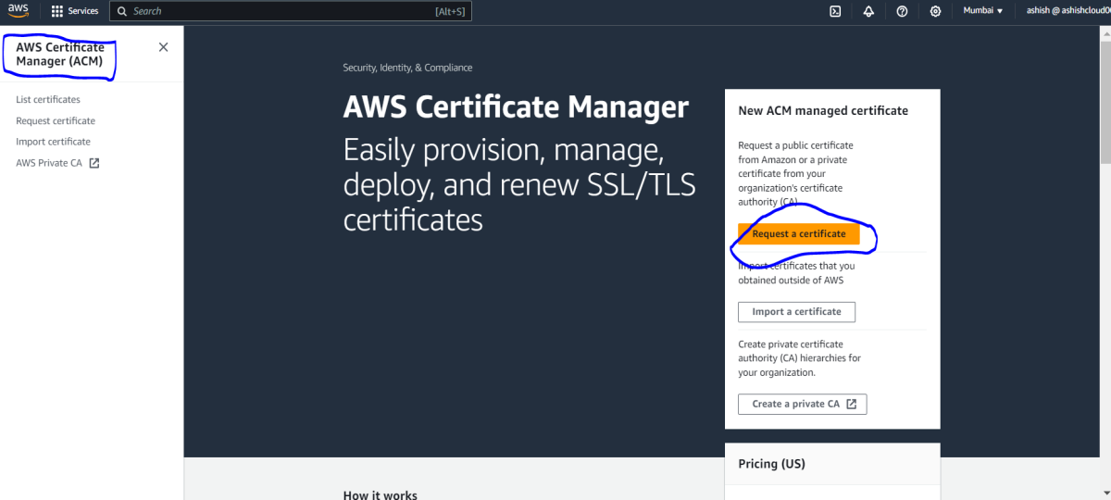

1. In **Request Certificate** goto **Certificate Type** and select **Request a public certificate.**
2. Then Click on **Next.**

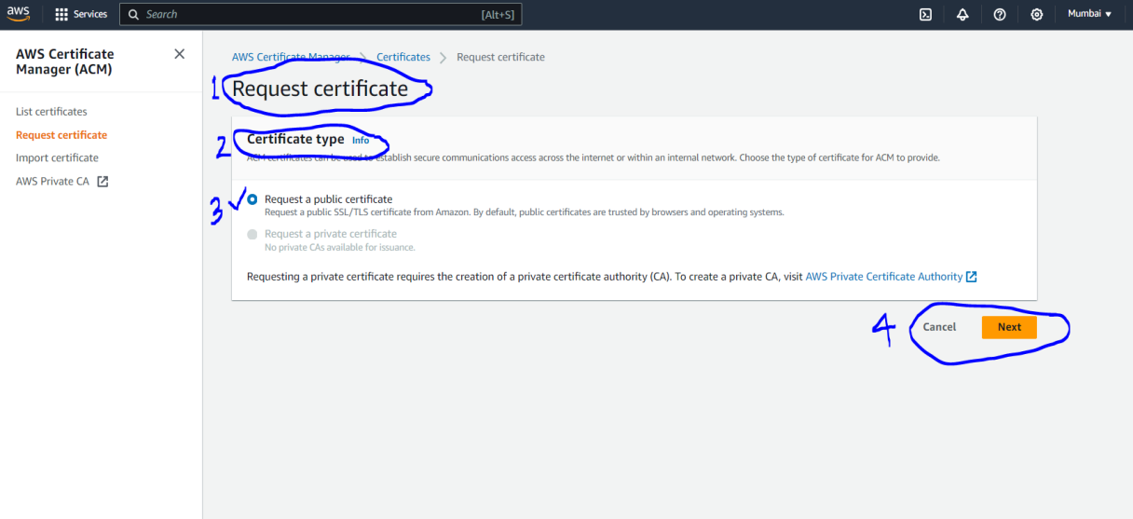

1. Then In **Request Public Certificate** goto **Domain Name** and enter Fully Qualified domain name(you need to buy from goDaddy, aws or somewhere else.)

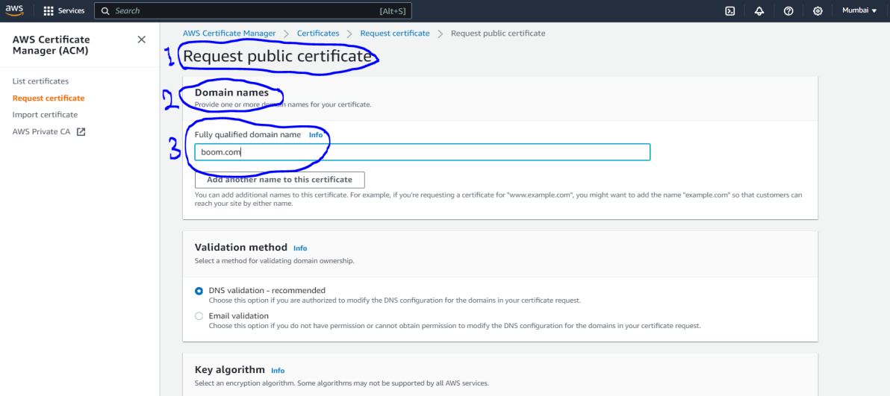

1. Then goto **validation Method** and select **DNS validation – recommended.**
2. **Then goto key Algorithm select RSA 2048.**
3. Then click on **Request**. To create certificate

